2024 Season
Auction draft format.

RK = Rank at the end of the season
Team = Team Name (Team owner)
REC = Record at the end of the season
PF = Points For; number of points the team scored that year. How strong of a team they were offensively.
PA = Points Against; number of points scored against the team that year. How strong or weak their competition was that year.
PF/G = Points For per Game; average number of points scored per game by the team that year
PA/G = Points Against per Game; avg number of points scored against the team per game that year
DIFF = Average point differential that year. + means scored more than opponents, - means scored less than opponents.
MOVES = number of trades, waiver wire acquisitions, player drops or other roster moves.

Final Records & Stats

RK | Team | REC | PF | PA | PF/G | PA/G | DIFF
1 | Jacobim Mugatu (Kevin Roth) | 10-4-0 | 1779.3 | 1437.5 | 127.1 | 102.7 | +24.4
2 | Pickens Some Flowers (Joe Rasar) | 8-6-0 | 1603.3 | 1574.9 | 114.5 | 112.5 | +2.0
3 | Sergeant Shultz (John Shultz) | 12-2-0 | 1671.6 | 1491.6 | 119.4 | 106.5 | +12.9
4 | Team Moe (jason moe) | 7-7-0 | 1601.4 | 1588.3 | 114.4 | 113.5 | +0.9
5 | Still Ain't Purdy (Andy Cross) | 10-4-0 | 1720.0 | 1502.9 | 122.9 | 107.4 | +15.5
6 | REAPER (rey salinas) | 8-6-0 | 1461.0 | 1562.2 | 104.4 | 111.6 | -7.2
7 | Marvin got me starvin (Garrett Hanstead) | 6-8-0 | 1576.4 | 1590.0 | 112.6 | 113.6 | -1.0
8 | Team Crandall (nick crandall) | 3-11-0 | 1443.5 | 1649.4 | 103.1 | 117.8 | -14.7
9 | UNCLE RICO (Matt Lehman) | 4-10-0 | 1547.7 | 1704.5 | 110.6 | 121.8 | -11.2
10 | Team Johnson (Robbie Johnson) | 6-8-0 | 1536.3 | 1597.8 | 109.7 | 114.1 | -4.4
11 | Team Oliver (Daniel Oliver) | 6-8-0 | 1545.4 | 1589.7 | 110.4 | 113.6 | -3.2
12 | Ultra MAGA Bruce (Bruce Lehman) | 4-10-0 | 1410.9 | 1608.0 | 100.8 | 114.9 | -14.1

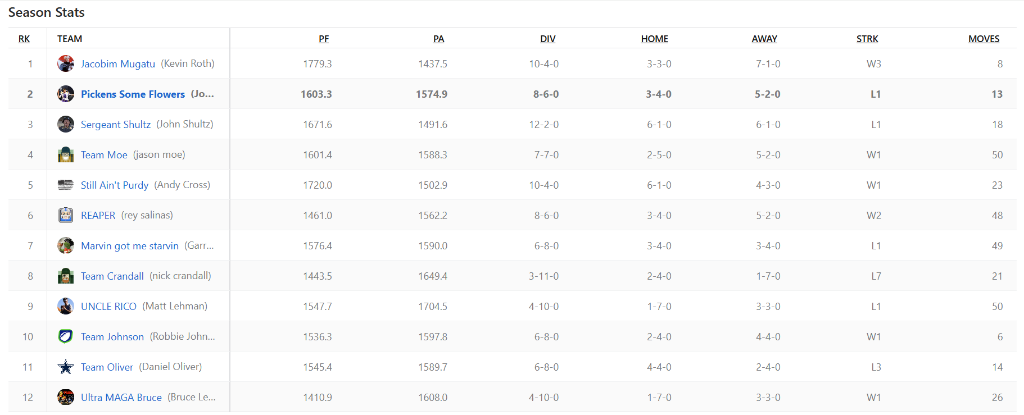

Season Stats
RK | Team
1 | Jacobim Mugatu (Kevin Roth)
2 | Pickens Some Flowers (Joe Rasar)
3 | Sergeant Shultz (John Shultz)
4 | Team Moe (jason moe)
5 | Still Ain't Purdy (Andy Cross)
6 | REAPER (rey salinas)
7 | Marvin got me starvin (Garrett Hanstead)
8 | Team Crandall (nick crandall)
9 | UNCLE RICO (Matt Lehman)
10 | Team Johnson (Robbie Johnson)
11 | Team Oliver (Daniel Oliver)
12 | Ultra MAGA Bruce (Bruce Lehman)

PF | PA | DIV | HOME | AWAY | STRK | MOVES
1779.3 | 1437.5 | 10-4-0 | 3-3-0 | 7-1-0 | W3 | 8
1603.3 | 1574.9 | 8-6-0 | 3-4-0 | 5-2-0 | L1 | 13
1671.6 | 1491.6 | 12-2-0 | 6-1-0 | 6-1-0 | L1 | 18
1601.4 | 1588.3 | 7-7-0 | 2-5-0 | 5-2-0 | W1 | 50
1720.0 | 1502.9 | 10-4-0 | 6-1-0 | 4-3-0 | W1 | 23
1461.0 | 1562.2 | 8-6-0 | 3-4-0 | 5-2-0 | W2 | 48
1576.4 | 1590.0 | 6-8-0 | 3-4-0 | 3-4-0 | L1 | 49
1443.5 | 1649.4 | 3-11-0 | 2-4-0 | 1-7-0 | L7 | 21
1547.7 | 1704.5 | 4-10-0 | 1-7-0 | 3-3-0 | L1 | 50
1536.3 | 1597.8 | 6-8-0 | 2-4-0 | 4-4-0 | W1 | 6
1545.4 | 1589.7 | 6-8-0 | 4-4-0 | 2-4-0 | L3 | 14
1410.9 | 1608.0 | 4-10-0 | 1-7-0 | 3-3-0 | W1 | 26

Final Week Scores

Winner's Bracket
- 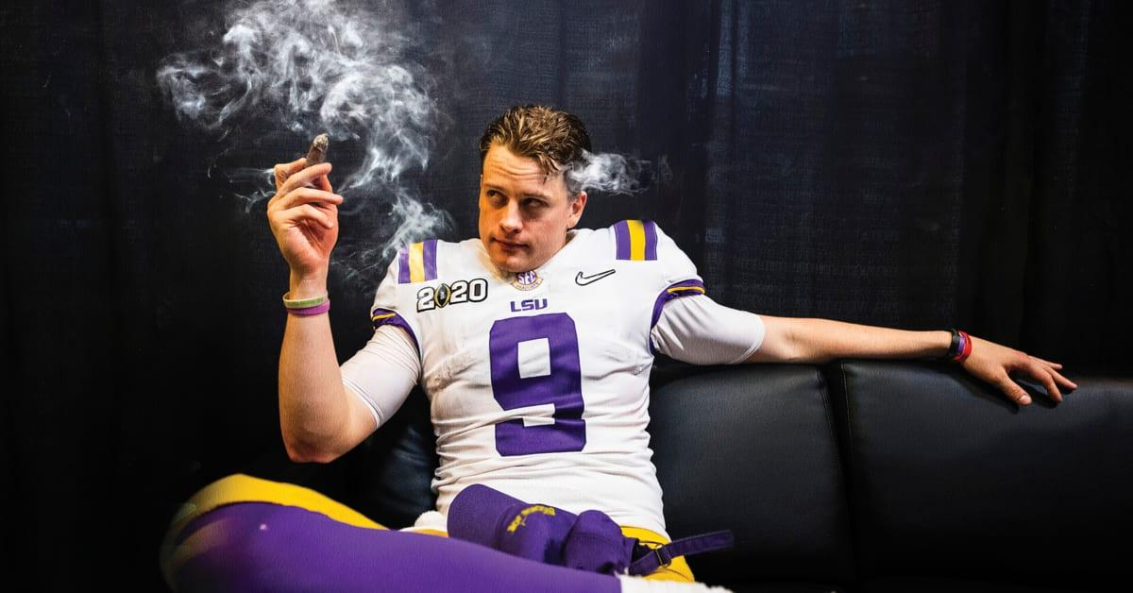
- Pickens Some Flowers
- (8-6-0, 2nd)
- 97.4
- 
- Jacobim Mugatu
- (10-4-0, 1st)
- 134.3
Box Score
CHAMPIONSHIP MATCHUP

Winner's Consolation Ladder
- Team Moe
- (7-7-0, 4th)
- 126.3
- 
- Sergeant Shultz
- (12-2-0, 3rd)
- 146.8
Box Score
- REAPER
- (8-6-0, 6th)
- 64.2
- 
- Still Ain't Purdy
- (10-4-0, 5th)
- 94.7
Box Score

Consolation Ladder
- Team Crandall
- (3-11-0, 8th)
- 122.1
- 
- Marvin got me starvin
- (6-8-0, 7th)
- 172.8
Box Score
- 
- UNCLE RICO
- (4-10-0, 9th)
- 135.0
- 
- Team Johnson
- (6-8-0, 10th)
- 130.3
Box Score
- 
- Ultra MAGA Bruce
- (4-10-0, 12th)
- 112.5
- 
- Team Oliver
- (6-8-0, 11th)
- 139.1
Box Score

Draft Results: See the 2024 - DRAFT RESULTS spreadsheet
In an auction draft each team gets $200 to spend on their roster. They can spend as much or little on any player they want as long as they have the budget. Every roster spot must be filled and a player must cost at least $1 or more. Players are randomly selected to be put up for auction and then all teams commence on bidding until the highest amount wins the player for their team. Market conditions, budget, timing, player values, all play huge factors in how a draft can turn out.

Jacobim Mugatu (Kevin Roth)

STARTERS |  | Offseason |  |  | 2024 season
SLOT | Player | %ST | %ROST | +/- | PRK | FPTS | avg | LAST
QB |   Lamar Jackson  BalQB | 91.7 | 99.9 | 0 | 1 | 446.1 | 26.2 | 22.9
RB |   Derrick Henry  BalRB | 93.4 | 99.9 | 0 | 3 | 358.4 | 21.1 | 33.1
WR |   Justin Jefferson  MinWR | 98.6 | 99.9 | 0 | 2 | 333.4 | 19.6 | 8.4
TE |   George Kittle  SFTE | 86.5 | 99.1 | -0.4 | 3 | 244.6 | 16.3 | 4.7
FLEX |   Jayden ReedQ  GBWR | 30.6 | 87.4 | -2.3 | 27 | 206.0 | 12.1 | 5.1
FLEX |   Terry McLaurin  WshWR | 69.2 | 96.3 | -0.6 | 7 | 280.8 | 16.5 | 20.2
FLEX |   Jalen McMillan  TBWR | 24.1 | 46.9 | +7.5 | 56 | 135.4 | 10.4 | 19.0
D/ST |   Buccaneers  TBD/ST | 42.3 | 53.1 | +1.6 | 16 | 118.0 | 6.9 | 2.0
 |  |  |  | TOTALS |  | 2122.7 | 129.23 | 115.4
Bench | 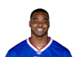  Amari Cooper  BufWR | 10.6 | 70.2 | -3.4 | 65 | 122.7 | 8.8 | --
Bench |   Najee Harris  LACRB | 44.6 | 90.2 | -1.1 | 20 | 210.6 | 12.4 | 15.6
Bench |   Cole Kmet  ChiTE | 7.2 | 30.3 | -1.7 | 19 | 120.4 | 7.1 | 2.3
Bench |   DeAndre Hopkins  BalWR | 16.7 | 77.6 | -5.3 | 49 | 147.0 | 9.2 | --
Bench |   Javonte Williams  DalRB | 17.7 | 71.1 | -3.3 | 31 | 157.9 | 9.3 | 10.8
 |  |  |  | TOTALS |  | 758.6 | 46.71 | 28.7
IR |   Empty | -- | -- | -- | -- | -- | -- | --

Pickens Some Flowers (Joe Rasar)

STARTERS |  | Offseason |  |  | 2024 season
SLOT | Player | %ST | %ROST | +/- | PRK | FPTS | avg | LAST
QB |   Joe Burrow  CinQB | 83.1 | 98.9 | 0 | 2 | 407.1 | 23.9 | 12.9
RB |   James Cook  BufRB | 66.5 | 96.3 | -2.7 | 7 | 280.7 | 17.5 | 8.8
WR |   Nico Collins  HouWR | 59.3 | 98.2 | -1.4 | 23 | 221.6 | 18.5 | 14.8
TE |   Hunter HenryQ  NETE | 30.3 | 63.4 | -6.5 | 12 | 147.4 | 9.2 | --
FLEX |   A.J. Brown  PhiWR | 62.1 | 97.4 | -2.5 | 18 | 230.9 | 17.8 | --
FLEX |   Aaron Jones  MinRB | 84.3 | 97.2 | -0.2 | 16 | 245.6 | 14.4 | 12.5
FLEX |   George Pickens  PitWR | 44.5 | 95.0 | -0.1 | 43 | 168.4 | 12.0 | 1.0
D/ST |   Packers  GBD/ST | 43.9 | 58.9 | +0.8 | 6 | 148.0 | 8.7 | 7.0
 |  |  |  | TOTALS |  | 1849.7 | 122.11 | 57.0
Bench |   Zay FlowersQ  BalWR | 61.7 | 95.5 | -0.5 | 22 | 222.5 | 13.1 | 3.1
Bench |   Kyle Pitts  AtlTE | 33.9 | 73.3 | -0.7 | 15 | 132.2 | 7.8 | 3.5
Bench |   D'Andre Swift  ChiRB | 58.1 | 92.8 | -1.2 | 19 | 219.5 | 12.9 | 12.5
Bench |   Bears  ChiD/ST | 10.1 | 20.0 | -0.8 | 9 | 134.0 | 7.9 | 15.0
Bench |   Gus Edwards  FARB | 6.9 | 46.0 | -5.1 | 58 | 64.1 | 5.8 | --
 |  |  |  | TOTALS |  | 772.3 | 47.49 | 34.1
IR |   Empty | -- | -- | -- | -- | -- | -- | --

Sergeant Shultz (John Shultz)

STARTERS |  | Offseason |  |  | 2024 season
SLOT | Player | %ST | %ROST | +/- | PRK | FPTS | avg | LAST
QB |   Justin Herbert  LACQB | 37.6 | 80.6 | +0.1 | 11 | 294.8 | 17.3 | 30.0
RB |   Joe Mixon  HouRB | 63.6 | 96.8 | -2.7 | 13 | 255.5 | 18.3 | 3.8
WR | 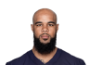  Keenan Allen  ChiWR | 45.0 | 84.0 | +0.4 | 36 | 187.4 | 12.5 | 3.5
TE |   Travis Kelce  KCTE | 65.4 | 94.4 | -5 | 5 | 197.4 | 12.3 | --
FLEX |   Mike Evans  TBWR | 88.0 | 98.5 | 0 | 14 | 247.4 | 17.7 | 17.9
FLEX |   James ConnerQ  AriRB | 52.2 | 85.4 | -11.8 | 11 | 265.8 | 16.6 | --
FLEX |   Tee Higgins  CinWR | 78.5 | 97.4 | +0.3 | 20 | 227.1 | 18.9 | 9.3
D/ST |   Chiefs  KCD/ST | 51.1 | 67.4 | -5.3 | 19 | 107.0 | 6.3 | 0.0
 |  |  |  | TOTALS |  | 1782.4 | 119.93 | 64.5
Bench | 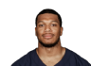  DJ Moore  ChiWR | 71.8 | 94.5 | 0 | 16 | 242.1 | 14.2 | 22.1
Bench |   Dameon Pierce  HouRB | 0.8 | 2.0 | +1 | 68 | 51.5 | 4.7 | 28.6
Bench |   Trey BensonQ  AriRB | 1.1 | 18.2 | -0.9 | 71 | 47.0 | 3.6 | --
Bench | 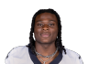  Kendre MillerQ  NORB | 7.7 | 32.7 | -10.2 | 89 | 29.1 | 4.9 | --
Bench |   Noah Gray  KCTE | 4.1 | 11.4 | -1.4 | 22 | 113.3 | 6.7 | 0.7
 |  |  |  | TOTALS |  | 483.0 | 34.05 | 51.4
IR |   Alvin KamaraQ  NORB | 32.5 | 95.4 | -1.6 | 9 | 274.3 | 19.6 | --

Team Moe (jason moe)

STARTERS |  | Offseason |  |  | 2024 season
SLOT | Player | %ST | %ROST | +/- | PRK | FPTS | avg | LAST
QB |   Jayden Daniels  WshQB | 75.2 | 99.0 | 0 | 5 | 366.3 | 21.5 | 4.1
RB |   Jonathan Taylor  IndRB | 85.6 | 99.9 | 0 | 10 | 268.7 | 19.2 | 27.0
WR |   Amon-Ra St. Brown  DetWR | 98.0 | 99.9 | 0 | 3 | 327.1 | 19.2 | 13.7
TE |   Chig Okonkwo  TenTE | 21.5 | 32.5 | +1.5 | 21 | 116.6 | 6.9 | 0.0
FLEX | 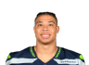  Zach Charbonnet  SeaRB | 55.0 | 90.2 | +8.1 | 25 | 191.9 | 11.3 | 9.1
FLEX | 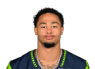  Jaxon Smith-Njigba  SeaWR | 68.4 | 93.5 | -0.4 | 10 | 259.0 | 15.2 | 5.3
FLEX |   J.K. Dobbins  LACRB | 35.8 | 84.9 | +7.8 | 24 | 196.8 | 15.1 | 10.5
D/ST |   Colts  IndD/ST | 33.1 | 43.3 | -26.7 | 14 | 119.0 | 7.0 | 5.0
 |  |  |  | TOTALS |  | 1845.4 | 115.5 | 74.7
Bench |   Khalil Shakir  BufWR | 28.9 | 74.8 | -6.8 | 34 | 189.5 | 12.6 | --
Bench | 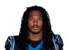  Rico Dowdle  CarRB | 50.3 | 82.4 | -0.6 | 22 | 205.8 | 12.9 | 16.4
Bench | 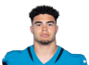  Brenton Strange  JaxTE | 6.5 | 13.4 | -1.9 | 32 | 91.1 | 5.4 | 10.0
Bench |   Dalton Kincaid  BufTE | 37.8 | 74.5 | -5.2 | 30 | 100.8 | 7.8 | --
Bench | 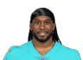  Alexander Mattison  MiaRB | 25.0 | 56.6 | -1.8 | 32 | 137.4 | 9.8 | 7.1
 |  |  |  | TOTALS |  | 724.6 | 48.42 | 33.5
IR |   David NjokuQ  CleTE | 26.0 | 78.8 | -5.9 | 11 | 148.5 | 13.5 | --

Still Ain't Purdy (Andy Cross)

STARTERS |  | Offseason |  |  | 2024 season
SLOT | Player | %ST | %ROST | +/- | PRK | FPTS | avg | LAST
QB |   Baker Mayfield  TBQB | 65.2 | 94.1 | +0.4 | 4 | 383.8 | 22.6 | 21.6
RB |   Josh Jacobs  GBRB | 93.8 | 99.4 | 0 | 6 | 299.1 | 17.6 | 11.6
WR | 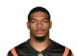  Ja'Marr Chase  CinWR | 98.1 | 99.9 | 0 | 1 | 430.0 | 25.3 | 25.6
TE |   Dalton Schultz  HouTE | 13.6 | 43.1 | -3.1 | 20 | 118.2 | 7.0 | 5.9
FLEX |   CeeDee Lamb  DalWR | 40.9 | 88.0 | -6.6 | 8 | 275.4 | 18.4 | --
FLEX | 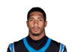  Chuba Hubbard  CarRB | 28.1 | 74.2 | -10.3 | 15 | 249.6 | 16.6 | --
FLEX |   Jakobi Meyers  LVWR | 42.5 | 81.4 | -1.2 | 21 | 224.0 | 14.9 | 29.3
D/ST |   Bengals  CinD/ST | 28.5 | 39.1 | -3 | 10 | 133.0 | 7.8 | 7.0
 |  |  |  | TOTALS |  | 2113.1 | 130.17 | 101.0
Bench |   Brock Purdy  SFQB | 31.7 | 81.6 | -9.5 | 14 | 279.5 | 18.6 | --
Bench | 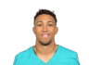  Nick Westbrook-Ikhine  MiaWR | 4.4 | 25.7 | -3.9 | 53 | 140.7 | 8.3 | 9.0
Bench | 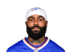  Elijah Moore  CleWR | 2.6 | 15.4 | -2.5 | 64 | 122.9 | 7.2 | 6.6
Bench |   Isaac GuerendoQ  SFRB | 50.2 | 82.3 | +3.6 | 49 | 94.2 | 5.9 | 0.5
Bench |   K.J. Osborn  WshWR | 0.0 | 0.1 | 0 | 144 | 18.7 | 2.3 | --
 |  |  |  | TOTALS |  | 656.0 | 42.36 | 16.1
IR |   Evan EngramQ  DenTE | 21.4 | 55.7 | -1.9 | 31 | 91.5 | 10.2 | --

REAPER (rey salinas)

STARTERS |  | Offseason |  |  | 2024 season
SLOT | Player | %ST | %ROST | +/- | PRK | FPTS | avg | LAST
QB |   Caleb WilliamsQ  ChiQB | 13.7 | 43.5 | -1.5 | 16 | 262.1 | 15.4 | 10.8
RB |   Isiah Pacheco  KCRB | 28.7 | 82.6 | -8.5 | 65 | 56.9 | 8.1 | --
WR |   Rome Odunze  ChiWR | 15.3 | 61.3 | -2.7 | 47 | 148.9 | 8.8 | 3.8
TE |   Mark Andrews  BalTE | 59.0 | 90.3 | -0.3 | 6 | 188.8 | 11.1 | 15.4
FLEX |   Bijan Robinson  AtlRB | 97.5 | 99.9 | 0 | 4 | 351.7 | 20.7 | 33.3
FLEX |   De'Von Achane  MiaRB | 91.4 | 99.3 | -0.2 | 5 | 306.9 | 18.1 | 20.1
FLEX |   Christian WatsonQ  GBWR | 10.9 | 55.1 | -2.8 | 74 | 110.3 | 7.4 | 0.0
D/ST |   Ravens  BalD/ST | 75.3 | 89.2 | +8.6 | 14 | 119.0 | 7.0 | 14.0
 |  |  |  | TOTALS |  | 1544.6 | 96.51 | 97.4
Bench |   Jordan Love  GBQB | 31.8 | 79.8 | -1.1 | 17 | 241.5 | 16.1 | 2.6
Bench |   Deebo Samuel Sr.  WshWR | 43.4 | 89.7 | -5.3 | 44 | 160.6 | 10.7 | --
Bench |   Tank DellQ  HouWR | 9.9 | 67.2 | -5.1 | 52 | 142.0 | 10.1 | --
Bench |   Sincere McCormickQ  LVRB | 1.3 | 11.2 | -2.6 | 92 | 27.2 | 5.4 | --
Bench |   Josh Downs  IndWR | 20.9 | 65.3 | +1 | 35 | 188.5 | 13.5 | 19.4
 |  |  |  | TOTALS |  | 759.8 | 55.85 | 22.0
IR |   Empty | -- | -- | -- | -- | -- | -- | --

Marvin got me starvin (Garrett Hanstead)

STARTERS |  | Offseason |  |  | 2024 season
SLOT | Player | %ST | %ROST | +/- | PRK | FPTS | avg | LAST
QB |   Bo Nix  DenQB | 43.4 | 81.8 | +0.8 | 7 | 326.8 | 19.2 | 35.5
RB |   Chase BrownQ  CinRB | 64.5 | 94.7 | -2.4 | 12 | 257.0 | 16.1 | --
WR |   Brian Thomas Jr.  JaxWR | 74.0 | 95.8 | +2 | 4 | 298.0 | 17.5 | 19.3
TE |   Trey McBride  AriTE | 93.4 | 99.1 | 0 | 2 | 255.8 | 16.0 | 19.5
FLEX |   Davante Adams  LARWR | 85.9 | 98.7 | -0.3 | 13 | 250.3 | 17.9 | 20.8
FLEX |   Malik Nabers  NYGWR | 84.7 | 99.0 | +0.1 | 6 | 283.6 | 18.9 | 18.4
FLEX |   Bucky Irving  TBRB | 81.7 | 95.4 | +3.1 | 14 | 250.4 | 14.7 | 16.4
D/ST |   Saints  NOD/ST | 24.9 | 35.0 | -0.5 | 20 | 106.0 | 6.2 | 4.0
 |  |  |  | TOTALS |  | 2027.9 | 126.55 | 133.9
Bench | 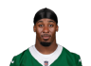  Breece Hall  NYJRB | 79.9 | 98.6 | -0.2 | 17 | 244.9 | 15.3 | 18.2
Bench |   Marvin Harrison Jr.  AriWR | 52.7 | 94.3 | -0.7 | 29 | 203.5 | 12.0 | 17.3
Bench |   Tyrone Tracy Jr.  NYGRB | 46.0 | 83.5 | -0.8 | 26 | 189.3 | 11.1 | 8.6
Bench | 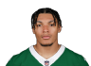  Braelon Allen  NYJRB | 3.2 | 26.0 | -3.5 | 51 | 85.2 | 5.0 | 4.3
Bench |   Will Levis  TenQB | 2.4 | 12.6 | -1.7 | 30 | 128.3 | 10.7 | 12.8
 |  |  |  | TOTALS |  | 851.2 | 54.12 | 61.2
IR |   MarShawn LloydQ  GBRB | 0.1 | 6.1 | +0.1 | 127 | 2.8 | 2.8 | --

Team Crandall (nick crandall)

STARTERS |  | Offseason |  |  | 2024 season
SLOT | Player | %ST | %ROST | +/- | PRK | FPTS | avg | LAST
QB |   Josh Allen  BufQB | 65.8 | 98.2 | -1.8 | 3 | 391.8 | 23.0 | 0.0
RB | 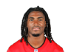  Rachaad White  TBRB | 55.6 | 90.2 | -1.9 | 23 | 199.6 | 12.5 | 0.0
WR |   Calvin Ridley  TenWR | 43.3 | 86.5 | -1.6 | 30 | 203.2 | 12.0 | 10.3
TE | 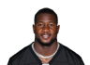  Jonnu Smith  MiaTE | 68.6 | 87.9 | -0.1 | 4 | 229.3 | 13.5 | 18.6
FLEX |   Drake London  AtlWR | 76.5 | 98.1 | -0.2 | 5 | 286.8 | 16.9 | 42.7
FLEX |   Rhamondre Stevenson  NERB | 46.3 | 87.9 | -2.4 | 28 | 177.9 | 11.9 | --
FLEX |   Ladd McConkey  LACWR | 56.2 | 89.5 | +0.3 | 12 | 250.9 | 15.7 | 16.5
D/ST |   Eagles  PhiD/ST | 76.8 | 89.7 | +2.5 | 12 | 129.0 | 7.6 | 3.0
 |  |  |  | TOTALS |  | 1868.5 | 112.96 | 91.1
Bench |   Quentin Johnston  LACWR | 19.8 | 56.2 | -0.5 | 39 | 181.7 | 12.1 | 33.6
Bench |   Wan'Dale Robinson  NYGWR | 8.4 | 37.4 | -0.6 | 38 | 182.7 | 10.7 | 14.3
Bench |   Tua TagovailoaQ  MiaQB | 11.8 | 56.0 | -7.9 | 21 | 194.9 | 17.7 | --
Bench | 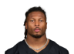  Tre Tucker  LVWR | 1.6 | 7.6 | -0.7 | 57 | 132.3 | 7.8 | 5.4
Bench |   Kareem Hunt  KCRB | 10.4 | 60.0 | -6.2 | 30 | 159.4 | 12.3 | --
 |  |  |  | TOTALS |  | 851.0 | 60.62 | 53.3
IR |   Empty | -- | -- | -- | -- | -- | -- | --

UNCLE RICO (Matt Lehman)

STARTERS |  | Offseason |  |  | 2024 season
SLOT | Player | %ST | %ROST | +/- | PRK | FPTS | avg | LAST
QB |   Kyler Murray  AriQB | 57.7 | 90.9 | -1.4 | 10 | 308.0 | 18.1 | 27.8
RB |   Saquon Barkley  PhiRB | 64.0 | 98.1 | -1.8 | 1 | 391.3 | 24.5 | --
WR |   Cooper Kupp  SeaWR | 50.7 | 93.0 | -5.3 | 37 | 184.0 | 15.3 | --
TE |   T.J. Hockenson  MinTE | 55.3 | 89.5 | +0.6 | 34 | 88.5 | 8.9 | 2.9
FLEX |   Tyreek HillQ  MiaWR | 71.1 | 98.2 | -0.4 | 19 | 227.2 | 13.4 | 4.0
FLEX |   Sam LaPorta  DetTE | 78.5 | 96.7 | +0.9 | 7 | 179.6 | 11.2 | 13.3
FLEX | 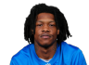  Jameson Williams  DetWR | 49.7 | 86.0 | +3.1 | 17 | 231.2 | 15.4 | 9.4
D/ST |   Bills  BufD/ST | 32.3 | 51.5 | -2.9 | 4 | 155.0 | 9.1 | 4.0
 |  |  |  | TOTALS |  | 1764.8 | 115.88 | 61.4
Bench | 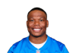  David Montgomery  DetRB | 19.8 | 70.6 | -3.9 | 18 | 223.6 | 16.0 | --
Bench |   Anthony RichardsonQ  IndQB | 19.5 | 50.9 | -1.3 | 25 | 171.4 | 15.6 | --
Bench |   Jameis WinstonQ  CleQB | 1.7 | 10.9 | -1.8 | 28 | 144.5 | 12.0 | --
Bench |   Brandin Cooks  DalWR | 3.2 | 15.1 | -0.4 | 97 | 69.6 | 7.0 | 4.0
Bench |   Jets  NYJD/ST | 26.4 | 40.7 | +0.4 | 22 | 104.0 | 6.1 | 16.0
 |  |  |  | TOTALS |  | 713.1 | 56.67 | 20.0
IR |   Empty | -- | -- | -- | -- | -- | -- | --

Team Johnson (Robbie Johnson)

STARTERS |  | Offseason |  |  | 2024 season
SLOT | Player | %ST | %ROST | +/- | PRK | FPTS | avg | LAST
QB |   Sam Darnold  SeaQB | 57.8 | 89.3 | +3.8 | 9 | 321.0 | 18.9 | 7.6
RB |   Kyren Williams  LARRB | 64.7 | 95.3 | -4.4 | 8 | 280.1 | 17.5 | --
WR |   Jordan Addison  MinWR | 63.1 | 92.0 | +2 | 24 | 218.5 | 14.6 | 1.0
TE |   Brock Bowers  LVTE | 90.9 | 99.1 | 0 | 1 | 269.7 | 15.9 | 15.0
FLEX |   Garrett Wilson  NYJWR | 75.4 | 98.1 | -0.5 | 9 | 259.9 | 15.3 | 9.1
FLEX |   Brian Robinson Jr.  WshRB | 59.7 | 93.2 | -0.5 | 29 | 166.8 | 11.9 | 2.6
FLEX |   Jerry Jeudy  CleWR | 37.3 | 83.3 | -1 | 11 | 254.9 | 15.0 | 12.3
D/ST |   Vikings  MinD/ST | 47.7 | 71.3 | -8.4 | 1 | 170.0 | 10.0 | 8.0
 |  |  |  | TOTALS |  | 1940.9 | 119.02 | 55.6
Bench | 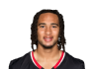  C.J. Stroud  HouQB | 26.2 | 73.7 | -3.3 | 18 | 226.5 | 13.3 | 6.0
Bench |   Travis Etienne Jr.  JaxRB | 48.0 | 87.3 | -1.3 | 36 | 130.2 | 8.7 | 9.0
Bench |   Jaylen Waddle  MiaWR | 22.0 | 80.7 | -2.5 | 45 | 153.6 | 10.2 | 9.0
Bench |   Mike Gesicki  CinTE | 11.2 | 28.1 | +2 | 13 | 144.5 | 8.5 | 14.8
Bench |   Empty | -- | -- | -- | -- | -- | -- | --
 |  |  |  | TOTALS |  | 654.8 | 40.74 | 38.8
IR |   Austin Ekeler  WshRB | 4.7 | 49.5 | -1.5 | 35 | 132.3 | 11.0 | 5.2

Team Oliver (Daniel Oliver)

STARTERS |  | Offseason |  |  | 2024 season
SLOT | Player | %ST | %ROST | +/- | PRK | FPTS | avg | LAST
QB |   Aaron Rodgers  FAQB | 18.3 | 49.9 | -3.9 | 15 | 263.1 | 15.5 | 24.8
RB | 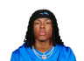  Jahmyr Gibbs  DetRB | 98.0 | 99.9 | 0 | 2 | 376.9 | 22.2 | 48.0
WR |   Puka Nacua  LARWR | 60.7 | 96.7 | -2.9 | 25 | 216.6 | 19.7 | --
TE |   Jake Ferguson  DalTE | 33.7 | 69.8 | -1.2 | 27 | 104.4 | 7.5 | 3.2
FLEX | 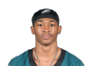  DeVonta Smith  PhiWR | 35.4 | 89.6 | -3.7 | 28 | 205.4 | 15.8 | --
FLEX |   Adam Thielen  CarWR | 39.2 | 68.7 | +5.6 | 51 | 144.5 | 14.5 | 9.4
FLEX |   Jauan Jennings  SFWR | 48.4 | 82.4 | -2.7 | 26 | 212.5 | 14.2 | 12.2
D/ST |   Jaguars  JaxD/ST | 11.3 | 14.4 | +0.2 | 31 | 77.0 | 4.5 | 3.0
 |  |  |  | TOTALS |  | 1600.4 | 113.74 | 100.6
Bench |   Tyler Lockett  FAWR | 5.1 | 49.5 | -1 | 68 | 121.0 | 7.1 | 4.8
Bench |   Darnell MooneyQ  AtlWR | 19.3 | 79.9 | -3.8 | 32 | 198.2 | 12.4 | --
Bench |   Zach Ertz  WshTE | 35.6 | 70.1 | +5.2 | 8 | 177.4 | 10.4 | 15.4
Bench | 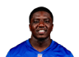  Devin Singletary  NYGRB | 7.8 | 46.4 | -1.5 | 46 | 96.6 | 6.4 | 2.7
Bench | 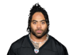  Jaylen Warren  PitRB | 25.3 | 72.4 | +4.9 | 39 | 124.1 | 8.3 | 2.1
 |  |  |  | TOTALS |  | 717.3 | 44.65 | 25.0
IR |   Jalen Hurts  PhiQB | 41.4 | 91.4 | -4.4 | 8 | 321.8 | 21.5 | --

Ultra MAGA Bruce (Bruce Lehman)

STARTERS |  | Offseason |  |  | 2024 season
SLOT | Player | %ST | %ROST | +/- | PRK | FPTS | avg | LAST
QB |   Patrick Mahomes  KCQB | 46.3 | 91.5 | -4.6 | 12 | 292.1 | 18.3 | --
RB |   Tony Pollard  TenRB | 43.2 | 88.8 | -0.8 | 21 | 206.7 | 12.9 | 6.2
WR |   DK Metcalf  PitWR | 60.7 | 96.3 | -0.9 | 30 | 203.2 | 13.5 | 14.3
TE |   Cade Otton  TBTE | 12.8 | 59.9 | -5.7 | 14 | 142.6 | 10.2 | --
FLEX |   Michael Pittman Jr.Q  IndWR | 29.7 | 78.7 | +1.2 | 42 | 169.8 | 10.6 | 13.2
FLEX |   Courtland Sutton  DenWR | 50.9 | 89.2 | -0.9 | 15 | 246.1 | 14.5 | 20.8
FLEX |   Xavier Worthy  KCWR | 23.5 | 78.9 | -2.8 | 33 | 190.2 | 11.2 | 0.0
D/ST |   Broncos  DenD/ST | 53.5 | 79.1 | +3.8 | 2 | 169.0 | 9.9 | 5.0
 |  |  |  | TOTALS |  | 1619.7 | 101.13 | 59.5
Bench |   Christian McCaffreyQ  SFRB | 15.1 | 60.0 | -0.8 | 70 | 47.8 | 12.0 | --
Bench |   Steelers  PitD/ST | 46.3 | 77.2 | -4.3 | 3 | 157.0 | 9.2 | 10.0
Bench |   Xavier LegetteQ  CarWR | 2.4 | 25.1 | -1.7 | 62 | 125.1 | 7.8 | 6.0
Bench |   Jared Goff  DetQB | 49.9 | 84.1 | +1.2 | 6 | 358.3 | 21.1 | 9.2
Bench |   Ameer AbdullahQ  LVRB | 9.9 | 31.6 | -1.7 | 38 | 127.2 | 7.9 | --
 |  |  |  | TOTALS |  | 815.4 | 58.03 | 25.2
IR |   Chris OlaveQ  NOWR | 14.9 | 66.2 | +0.1 | 93 | 78.7 | 9.8 | --

